6 Functions and Mix-Ins

Contents

What are Functions in SASS? 1

Creating your first SCSS function 1

Mix-ins 3

Creating a Mix-In 5

How to include the mixin in your CSS rule 6

Mixins Arguments 7

Remember in SASS a Word is just a Word 9

Make sure you have watch SASS on

# What are Functions in SASS?

Functions in Sass are very similar to functions that are in JavaScript. So, if you are familiar with JavaScript, you should find this function stuff to be much easier to get the hang of.

# Creating your first SCSS function

Go to your **main.scss** file

We are going to be placing the functions right under our import statements on the page. Notice that what is in the parenthesis is $weight-name, this was a made up variable name, but it will represent the font -weights, font-weights is the official CSS name, and inside that is the weight of bold. so now our own variable that we threw in the parenthesis will take the place of that official name.

map-get (official name, our name)

@function weight($weight-name) {

    @return map-get($font-weights, $weight-name);

}

This will be simplifying some of our code, so it does not look so clucky.

Scroll down to where you wrote that nested code. We will be targeting this line of code.

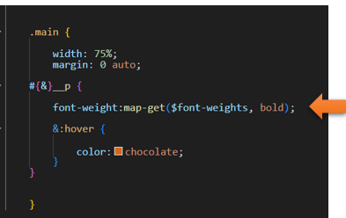

…and with our new function, we can change it to this: We also changed the code from bold to regular, but it is much simpler to write now.

 .main {

        width: 75%;

        margin: 0 auto;

    #{&}__p {

        font-weight:weight(regular);

        &:hover {

            color:chocolate;

        }

    }

    }

bold

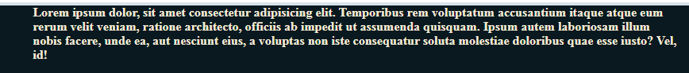

regular



# Mix-ins

Mix-ins are similar to functions.

Go to the **index.html** file and add another paragraph

highlight the entire paragraph on the page, and **alt- shift -down arrow**.

Watch it, do not duplicate the entire div with the class of main, we are only duplicating the paragraph with in it.

<div class="main">

<p class="main__p">First paragraph in main.Lorem ipsum dolor, sit amet consectetur adipisicing elit. Temporibus rem voluptatum accusantium itaque atque eum rerum velit veniam, ratione architecto, officiis ab impedit ut assumenda quisquam. Ipsum autem laboriosam illum nobis facere, unde ea, aut nesciunt eius, a voluptas non iste consequatur soluta molestiae doloribus quae esse iusto? Vel, id!</p>

<p class="main__p">First paragraph in main.Lorem ipsum dolor, sit amet consectetur adipisicing elit. Temporibus rem voluptatum accusantium itaque atque eum rerum velit veniam, ratione architecto, officiis ab impedit ut assumenda quisquam. Ipsum autem laboriosam illum nobis facere, unde ea, aut nesciunt eius, a voluptas non iste consequatur soluta molestiae doloribus quae esse iusto? Vel, id!</p>

</div>

Back in the **main.SCSS**.

Add the top 3 lines to your **.main** rule

        display:flex;

        justify-content: center;

        align-items: center;

.main {

        display:flex;

        justify-content: center;

align-items: center;

padding-top: 5%;

        width: 75%;

        margin: 0 auto;

    #{&}__p {

        font-weight:weight(regular);

        &:hover {

            color:chocolate;

        }

    }

    }

Watch it, remember if you do not have Watch SASS on, you will not be able to view this

**Save** that SASS file and then switch back to the index.html file. And it now is flexible with size of viewport.

Yes it looks bad, with out a gap between columns but we will fix that. And you will find that by default if you have more than one paragraph inside of one div it will default to columns.

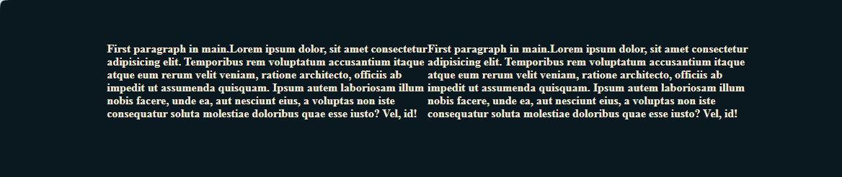

# Creating a Mix-In



Inside of your main.SCSS file

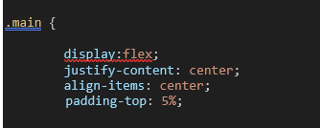

display:flex;

        justify-content: center;

        align-items: center;

Cut those top 3 lines from the rule properties that we just added to .main, and put them into our new mixin. We are also adding a gap to make the inbetween sections of the paragraphs look better

@mixin flexCenter() {

    display:flex;

    justify-content: center;

    align-items: center;

    gap: 35px;

}

You are going to place the mixin before your first tag, which for us is the body tag, and after The maps

z

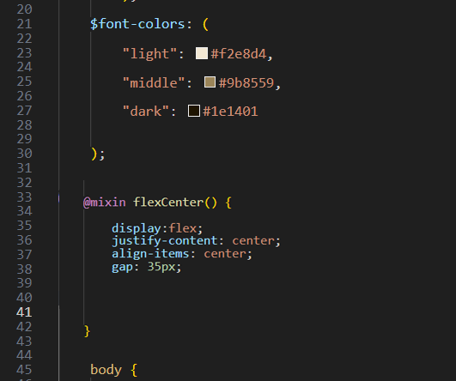

# How to include the mixin in your CSS rule

Now that you have defined the mixin, you need to know how to place it into your rule so that our .main can use it.

@include flexCenter;

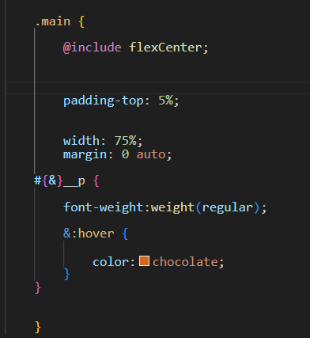

Now, Save it and go back to index.html, to test the code

… and it is still reading the code correctly!

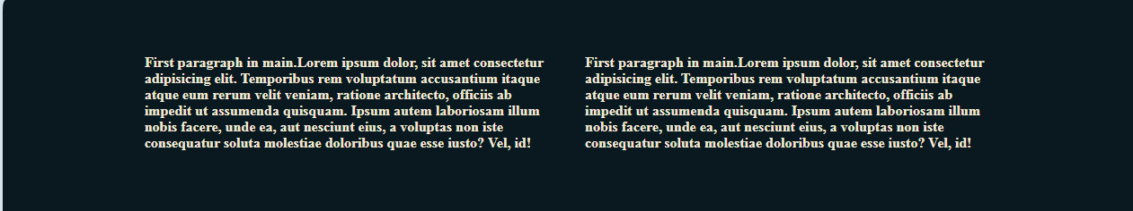

and when we hover…

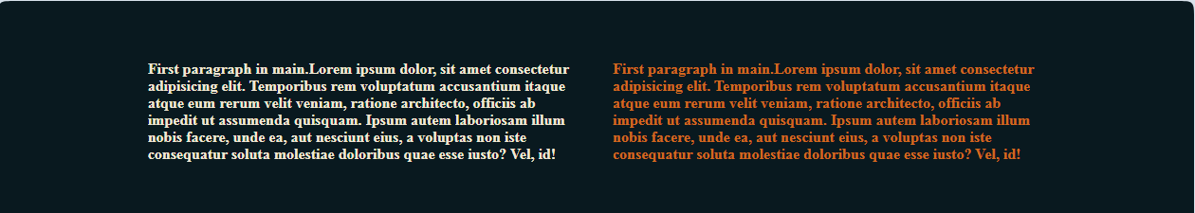

# Mixins Arguments

Remember to turn on SASS

Ok, we are going to start out by giving our second paragraph a different class name in the index.html page.

In our index.html file

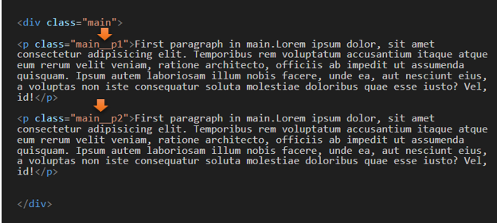

In Our main. SCSS file

go to our @mixin flexCenter and pass in the variable of $direction

Then inside the rule, add the line that says flex-direction: $direction;

@mixin flexCenter($direction) {

    display:flex;

    justify-content: center;

    align-items: center;

    gap: 35px;

    flex-direction: $direction;

}

Now go to the rule for .main, and make changes to use this new argument of direction. We add parenthesis and inside, we fill in the blank for $direction. We now want our paragraphs to display in a row, instead of a direction.

.main {

        @include flexCenter(column);

So, now the display is in a column instead of the rows that we had before

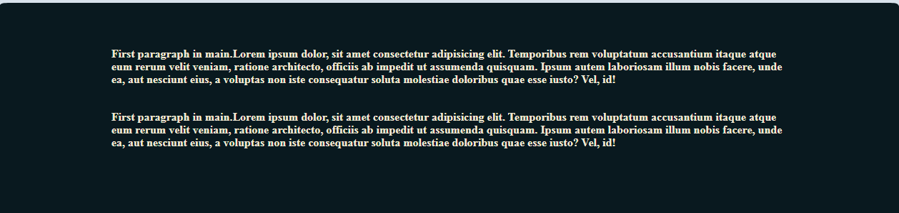

To get the hovers to work again just change those classes on the paragraph tag back to what it was

In the index.html file

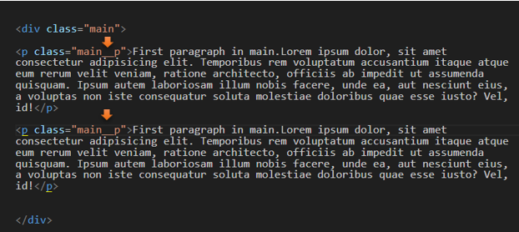

In the main. SCSS file

Now our hover will work again

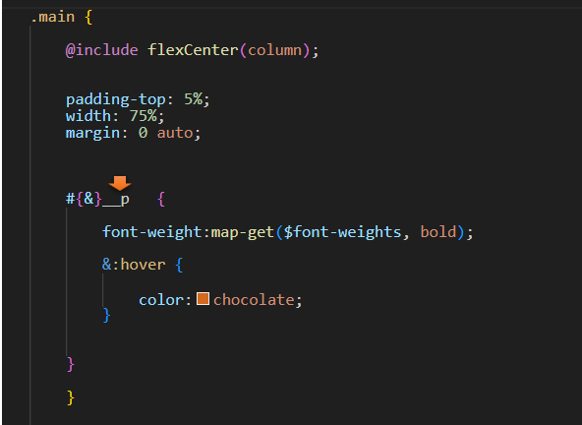

All Better

